Prelude and Fugue in C Major, BWV 545 J. S. Bach (1685 – 1750)

Meditation on Brother James’s Air Harold Darke (1888 – 1976)

Valet will ich dir geben, BWV 736 J. S. Bach
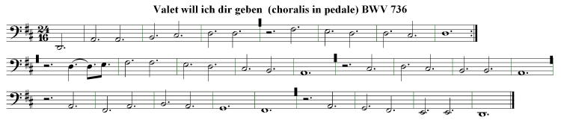

Suite Médiévale, Op. 56 (1947) Jean Langlais (1907 – 1991)
V. Acclamations
(sur le texte des Acclamations Carolingiennes)

Käthe Wright Kaufman is the organ scholar at Peterborough Cathedral for the 2019-2020 year. In May 2019 she completed her MMus degree as a student of David Higgs at the Eastman School of Music in Rochester, New York. A native of Chicago, she has pursued her organ studies since 2007, studying also with James R. Brown, William Porter, and Edoardo Bellotti. Following the completion of her BMus degree from Eastman in 2016, Käthe spent a gap year in Truro where she served as organ scholar at the cathedral there. She has performed for the American radio program Pipedreams Live!, and she has performed in venues around the United States and the United Kingdom. Käthe has received numerous awards, including the Gerald Barnes Award for Excellence in Pipe Organ (2013), the inaugural VanDelinder Prize in Liturgical Organ Skills (2014), first place in the West Chester University International Organ Competition (2015), and second prize in the Fox Valley AGO Competition (2018).

